An invitation to hear . . .

Local Novelists at Evanston Public Library
reading from their novels

Esther Yin-Ling Spodek’s We Have Everything Before Us
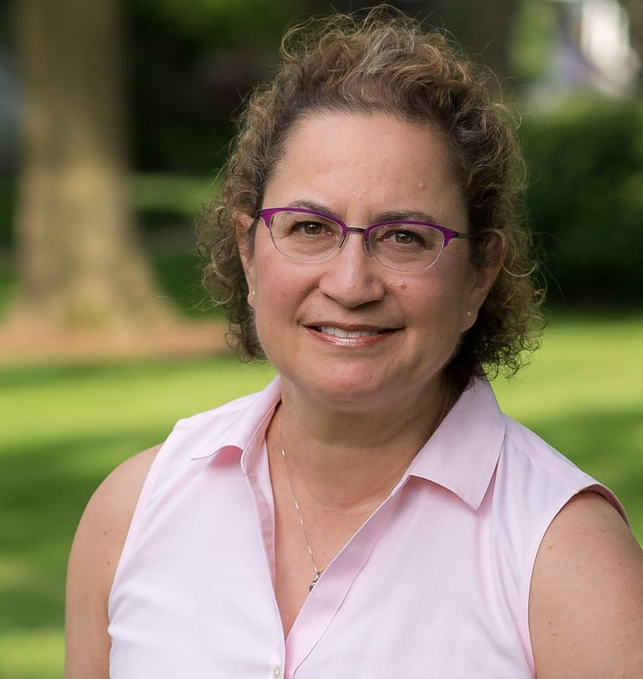
Three women must decide how to move forward in this humorous and dramatic tale of intersecting lives.

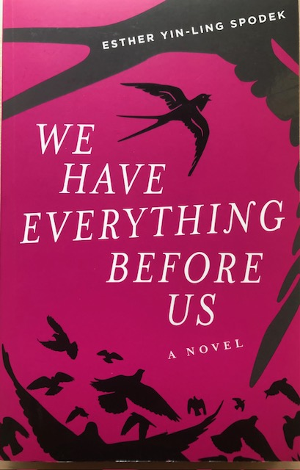

Nancy Burke’s Undergrowth
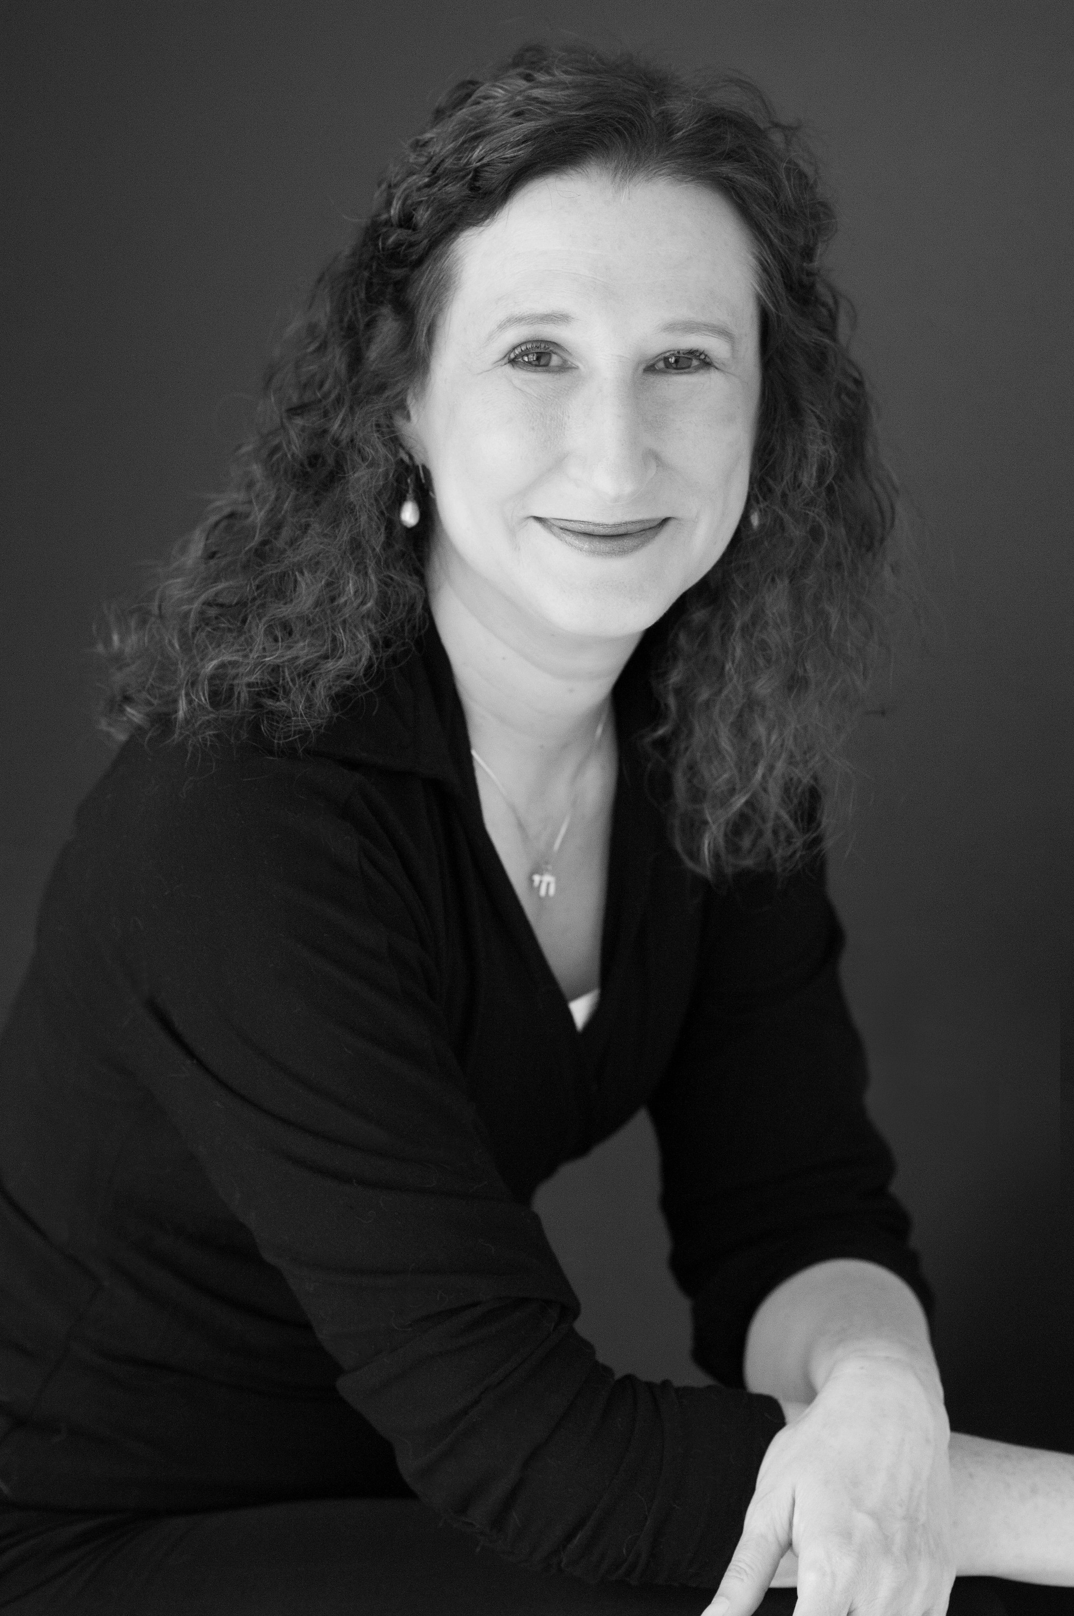
In 1960s Brazil, an indigenous group is on the brink of a tragedy, the dimensions of which
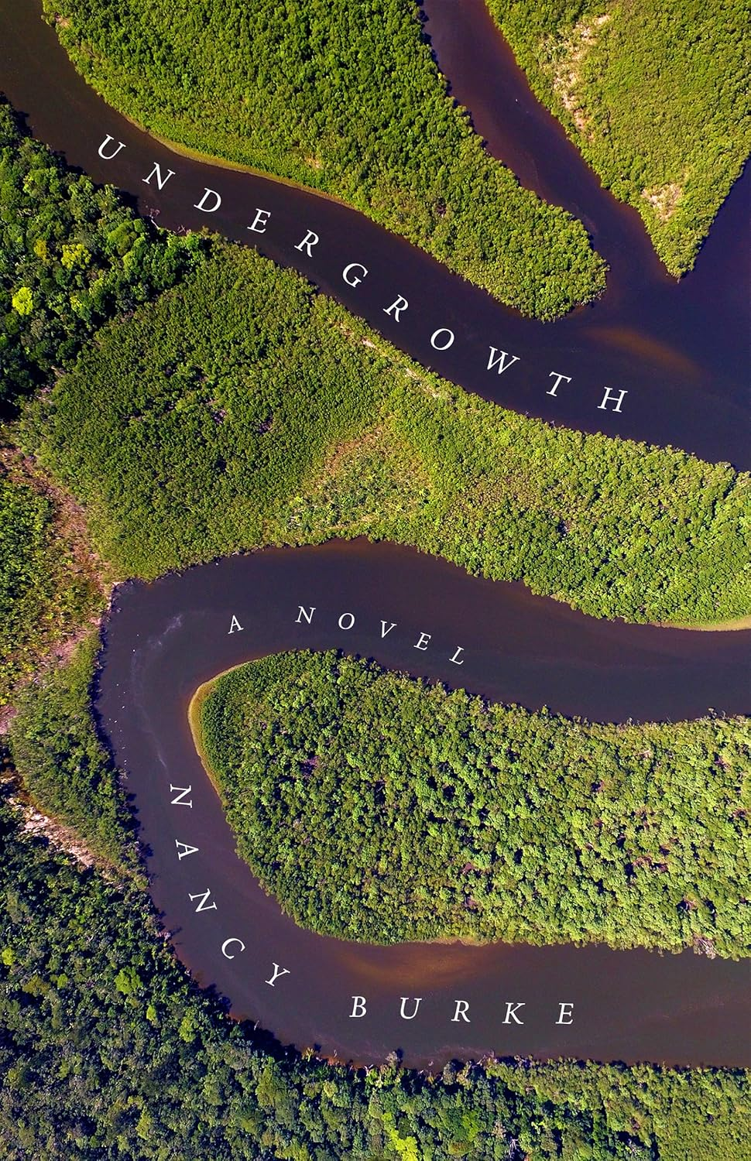
they are only beginning to grasp....

Joyce Goldenstern’s In Their Ruin

This novel does a brilliant job of presenting Chicago’s working class as it was 75 years ago
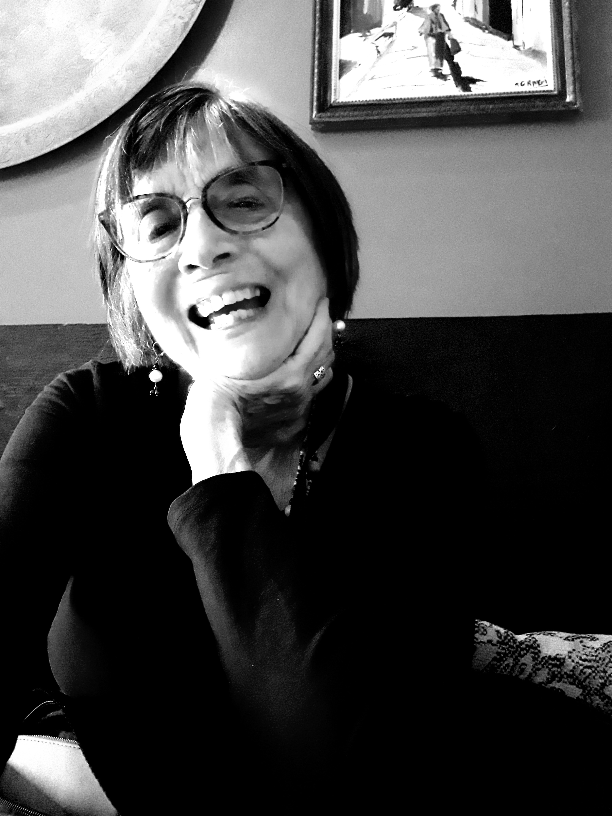
and as it has changed.
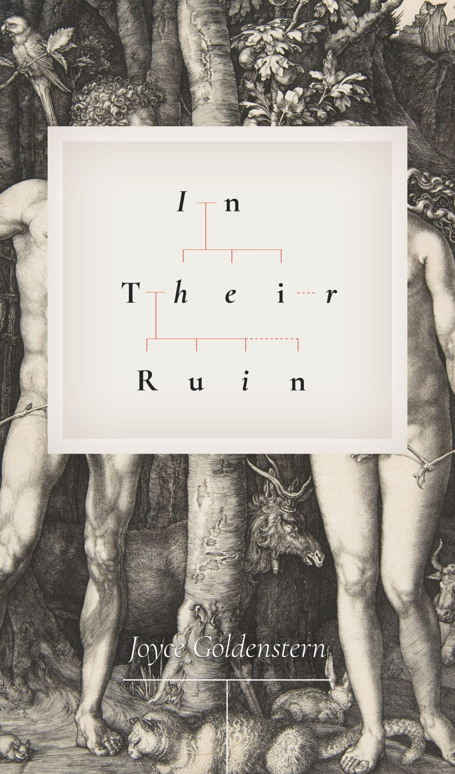

Wed. April 23, 6 p.m. 1703 Orrington Ave. Free and Open to the public.
Refreshments will be served.

